

The Oil Spill Program

Using Recursion To Peek In All Directions Within A Matrix
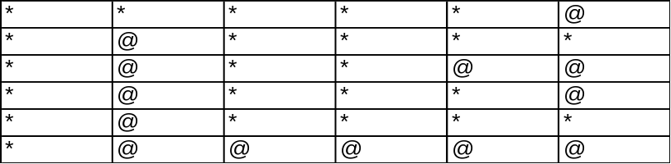

public class OilSpill
{
public static void main (String[] args)
{
int size1 = 8, size2 = 8; int oilpockets = 0;
char[][] field = new char[100][100];

// Input The Data For Field Matrix (Pad Around Sides With ‘*’)
inputMethod (size1, size2, field);
for (int i = 1; i <= size1-2 ; i++)
for (int j = 1; j <= size2-2 ; j++)
oilpockets = checkCurrBlock(field, i, j, oilpockets,
size1, size2);
System.out.println(“Total Oil Pockets = “ + oilpockets);
}

private static int checkCurrBlock (char[][] field, int i, int j,
int oilpockets, int size1, int size2)
{
if (field[i][j] == '@')
{
checkSurroundings(field, i, j, size1, size2);
oilpockets++;
}
return oilpockets;
}

private static void checkSurroundings (char[][] field, int i, int j,
int size1, int size2)
{
if (field[i][j] == '@')
{
field[i][j] = '*';
checkSurroundings (field, i-1, j, size1, size2);
checkSurroundings (field, i-1, j-1, size1, size2);
checkSurroundings (field, i-1, j+1, size1, size2);
checkSurroundings (field, i, j-1, size1, size2);
checkSurroundings (field, i, j+1, size1, size2);
checkSurroundings (field, i+1, j-1, size1, size2);
checkSurroundings (field, i+1, j+1, size1, size2);
checkSurroundings (field, i+1, j, size1, size2);
}
}
}

A Whole New Way To Do A Binary Search

Using Recursion


public class Binary
{
public static void main(String[] args)
{
String[] s = {"Karen", "John", "Matt", "Suzy"};

System.out.println(binarySearch(s,0,s.length-1,"Matt");
}

public static int binarySearch(Object[] a, int first, int last,
Object key)
{
if (first <= last)
{
int mid = (first + last) / 2;

Object midVal = a [mid];

int comp = ((Comparable)midVal).compareTo (key);

if (comp < 0)
return binarySearch (a, mid + 1, last, key);

if (comp > 0)
return binarySearch (a, first, mid - 1, key);

return mid; // key found

} // if first <= last
return -first - 1; // key not found; belongs at a [first]

} // method binarySearch
}
Answers to Recursion Homework Practice (p. 332 #1 – 5, p. 334 #25)

void F (char ch)
{
if ( ('A' <= ch) && (ch <= 'H') )
{
F(ch + 1);
cout << ch;
}
else
cout << endl;
}

1. F(‘C’) gives us ABC

2. F(‘G’) gives us ABCDEFG

3. F(‘3’) gives us a blank line

4. If ch – 1 is replaced by ch + 1, the call F(‘C’) gives us HGFEDC

5. If the output statement and recursive call were reversed, F(‘C’) gives us CBA

25. Write a recursive function to display the digits of any nonzero integer in reverse order.

void display (int num)
{
if (num > 0)
{
cout << num % 10 << endl;
display (num / 10);
}
}

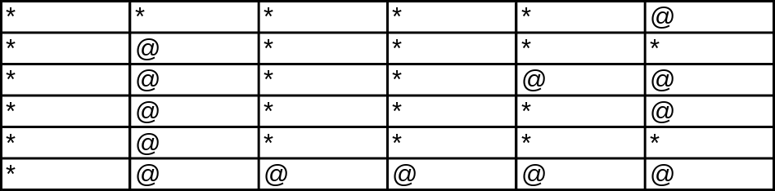void main ()
{
int size1 = 8, size2 = 8; int oilpockets = 0;
char Field[100][100];

// Input The Data For Field Matrix
// (Pad Around Sides With ‘*’)
InputFunction (size1, size2, Field);

for (int i = 1; i <= size1; i++)
for (int j = 1; j <= size2; j++)
CheckCurrBlock(Field,i,j,oilpockets,size1,size2);
cout << “Total Oil Pockets = “ << oilpockets << endl;
}

void CheckCurrBlock (char Field[][100], int i, int j,
int& oilpockets, int size1, int size2)
{
if (Field[i][j] == '@')
{
CheckSurroundings(Field, i, j, size1, size2);
oilpockets++;
}
}

void CheckSurroundings (char Field[][100],int i,int j,
int size1,int size2)
{
if (Field[i][j] == '@')
{
Field[i][j] = '*';
CheckSurroundings (Field,i-1,j,size1,size2);
CheckSurroundings (Field,i-1,j-1,size1,size2);
CheckSurroundings (Field,i-1,j+1,size1,size2);
CheckSurroundings (Field,i,j-1,size1,size2);
CheckSurroundings (Field,i,j+1,size1,size2);
CheckSurroundings (Field,i+1,j-1,size1,size2);
CheckSurroundings (Field,i+1,j+1,size1,size2);
CheckSurroundings (Field,i+1,j,size1,size2);
}
}

